Wordpress Lightning Paywall

Donation Button

1 Donation Button 1
1.1 User view 1
1.2 Publisher view 1
2 Donation Button with additional fields (Content Store) 2
2.1 User view 3
2.2 Publisher view 3
3 Donate with Comment / Pay-per-Comment 4
3.1 User view 4
3.2 Publisher view 5
4 Inspiration 6
4.1 Example applications on other websites 6
4.2 Wordpress Donation Plugin (PayPal, Creditcard) 6

The Donation button is a Lightning payment as Grant, Support or Donation.

YouTubers, bloggers, influencers, and content providers are offered the opportunity to receive financial support from their fans and visitors in the form of Bitcoin and Lightning.

Donation Button

User view

The Donation Button should be able to be inserted as a block / element at any place within a Wordpress page.
Be it in the footer, in the sidebar or in a place within a blog post.

The donor has the possibility to specify the amount and the corresponding currency. The default value is Satoshi.

After the donor has entered the amount, he clicks on the Donation button and the QR code is displayed.

The donor has the opportunity to make a donation to the site operator on a web page.

Publisher view
The publisher can insert a block / element to the desired place within his web page.

- He can edit this block and there should be the following fields:
- Mass of the Donation Window (Default 250x250)
- Title
- Description
- Button Text (Default Donate now)
- Amount
- Currency
- Link to Thank you Page
- Background Color Editor (Default: #E6E6E6 )
- Donation Button Editor (Default. #FE642E)
- Cover picture (funny feature)

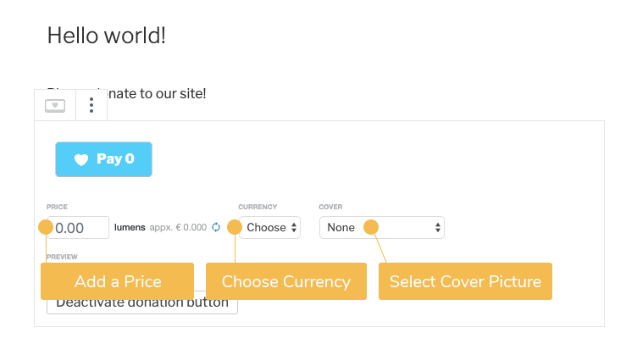

Donation Button with additional fields (Content Store)

This is an extension of the Donation Button. In addition to the functions of the Donation Button, additional fields can be queried, which will be notified to the publisher when the donation is paid.

The notification is sent to the email address that has been stored in the Wordpress backend.

The additional fields should be defined as optional or mandatory by the publisher.
The following fields can be for example:

- Email-Adresse
- Name
- Adresse
- Phone Number

User view
In the following example, the donor can enter his email address and a comment and then donate an amount.
The information provided will then be sent to the publisher's email address.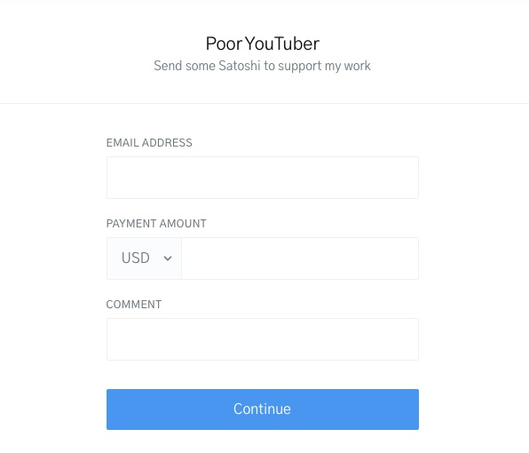

The link to the donation page with additional fields is here:

https://checkout.opennode.com/p/ff188885-645e-41ed-97c7-b2695b3b0397

Publisher view

The publisher can edit the Donation Button with additional fields as follows:
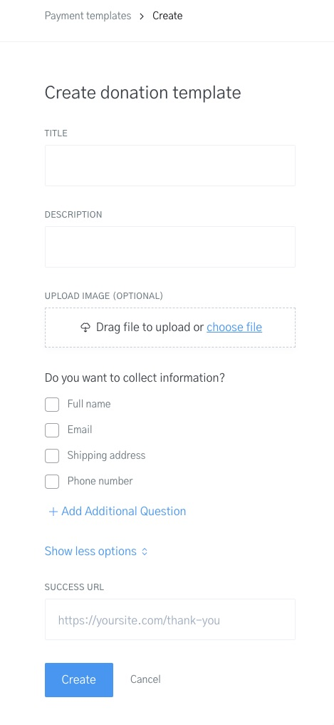

Donate with Comment / Pay-per-Comment
With pay-per-comment, the donor can specify a comment that will be displayed on the publisher's website.

User view

The donor enters the amount he would like to donate.
In addition, he can leave a comment and writes a corresponding message. He can specify his name or username, which will then also appear on the page, or as an anonymous donor.

A donation with comment function: https://tallyco.in/s/x8t1qu/

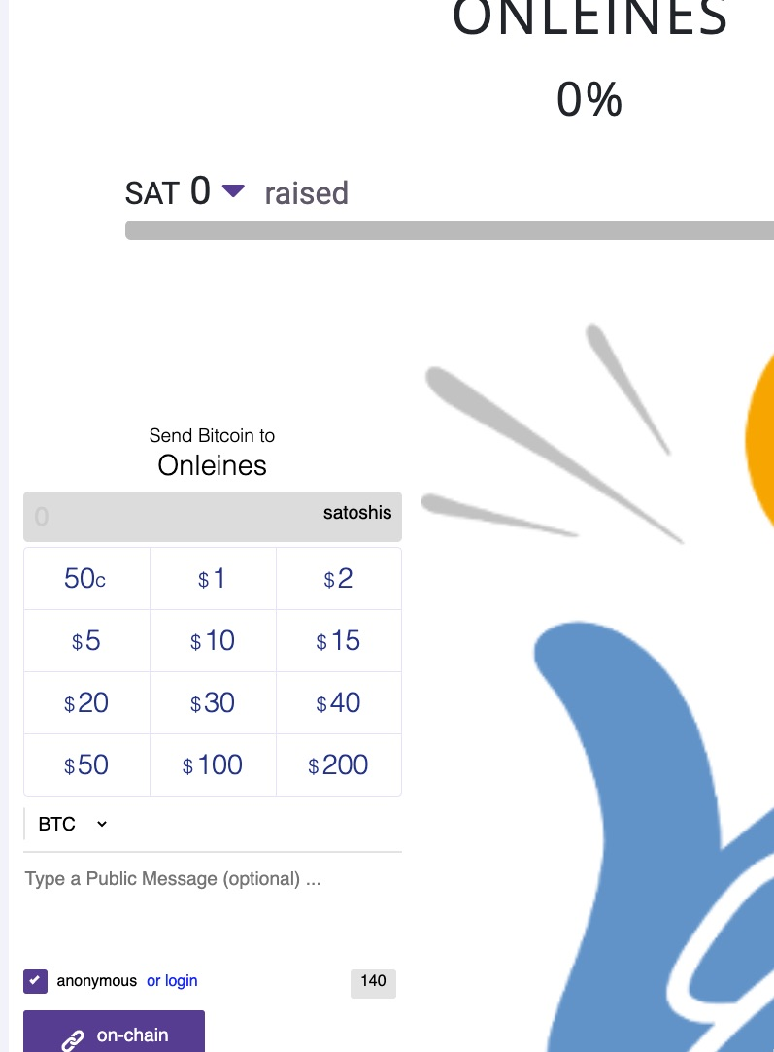

Publisher view

This feature may need to interact with the wordpress Comments feature or the submission form for it to work.

Like: https://wpforms.com/how-to-require-users-to-pay-to-submit-a-post-in-wordpress/
https://formidableforms.com/wordpress-users-pay-per-post/

Inspiration

Example applications on other websites
https://anitaposch.com/donate-support Donation overview by Anita Posch

https://thebiz.pro/ contribute to unlock a podcast

https://btcpay.lightning-solutions.eu/apps/3EeJS7R9An8AfYkzS4caLrKGSjZY/pos

Magic Future Money from Brumi
https://magicfuturemoney.de/wettbewerb/faq-fragen-antworten/#unterst%C3%BCtzen

Magic future money based on the solution from Brumi.
https://kosmos.social/@bumi bzw. https://michaelbumann.com/
https://github.com/bumi/lnme Donation with a short message
https://github.com/bumi/area402-widget das widget für die spende?

Giving Block
Giving Block https://www.thegivingblock.com/why-donate-bitcoin offer Donation.
One Client example:: https://signal.org/donate/#cryptocurrency

Wordpress Donation Plugin (PayPal, Creditcard)
Inspiration which donation functions can be implemented on the basis of Wordpress. In these examples the payment is always realized with the payment methods like credit card and Paypal. Also as a recurring payment.

It should only serve as a suggestion. With Bitcoin and Lightning no subscription payments can be implemented.

Also, the donation without Anledung and registration should be possible and anonymous if desired.

https://www.elegantthemes.com/blog/wordpress/best-wordpress-donation-plugins und als YouTube Video über 5 WP Donation plugins: https://www.youtube.com/watch?v=tXPkGNKbInk

Donorbox: WP: https://wordpress.org/plugins/donorbox-donation-form/ und bei YouTube https://www.youtube.com/watch?v=NDuwbbheU5I

https://givewp.com/

PayPal Donation Wordpress Button: https://wordpress.org/plugins/paypal-donations/ and YouTube https://www.youtube.com/watch?v=oNRrN9qvUxI&t

